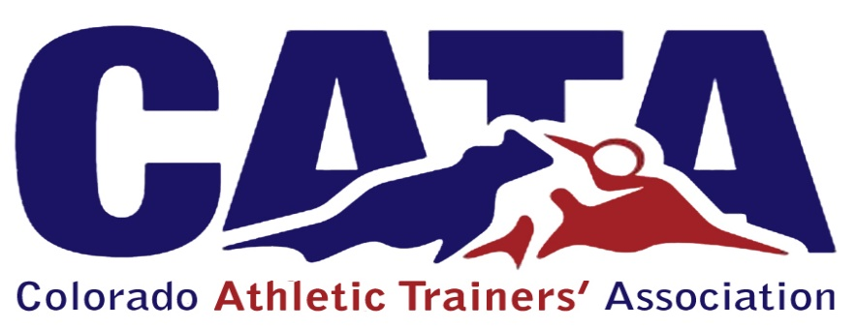

Communications/PR
Members: Member at Large, Secretary, Public Relations, members deemed necessary.
    - The purpose, objectives, and functions of the Communications Committee shall be:
      - Maintaining the organization website that shall include, but not be limited to, the following:
        - Contact information for the board members and committees
        - Important Association documents.
        - Information provided by the board members and committees.
        - Items of interest to the members of Association related to the profession of athletic training.
        - Links to the other athletic training Associations.
      - Communicating necessary information with the membership through newsletters and e-blasts, that shall include, but not be limited to, the following:
        - Summaries of the proceedings of previous meetings
        - Notification of Board and Membership meetings.
        - Information provided by Board members.
        - Items of interest to the members of the Association related to the profession of athletic training.
      - Coordinate social media sites of the CATA, including but not limited to Facebook, Twitter, and Instagram.

TERMS:
1. Chair: 4 years
2. Member: 3 years

