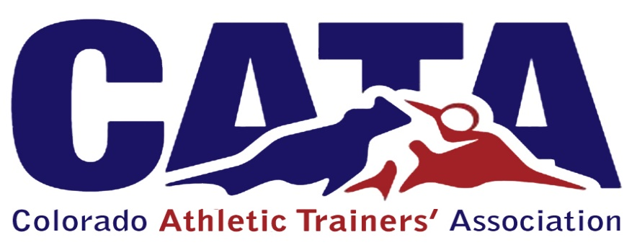

Multi-Setting Committee
Chair: as appointed
Members shall constitute, but are not limited to, the following disciplines of Athletic Training: Secondary Schools, Professional Sports, Industrial, Collegiate Clinical, Non-Traditional
    - The Purpose of the Multi-Setting Committee is as follows
      - To work together across all professional settings in Colorado to promote unity with in the Athletic Training Profession
      - To work together across all professional settings to collaborate on solutions, ideas and resources for areas of concern amongst Athletic Trainers in Colorado.
      - To listen to colleagues within each setting and bring concerns to the committee to brainstorm possible solutions
      - Report any pertinent information and concerns to the Board of Directors.
    - Each discipline may form a subcommittee structure appropriately supportive of their specific discipline.

TERMS:
1. Chair: 4 years
2. Member: 3 years

